**Assignment 3 – Sqoop and Pig**

1. Create table **Employee** inside database **EmployeeInfo** and load the content from **EmployeeNoheader.csv** to this table. Then query the created database to show the info of employees with **salary >1500**

Required Figure 1: the screenshot of sql query and the result

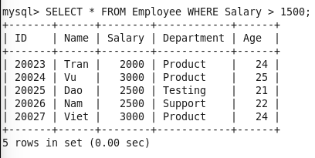

2. Use Sqoop import to get id, name, and salary of employees in Employee table and save results in **Employee2000plus** directory. Then show the imported results.

Required Figure 2: screenshot of sqoop command

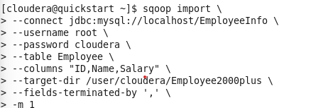

Required Figure 3: screenshot of hdfs dfs -cat command to show the imported results

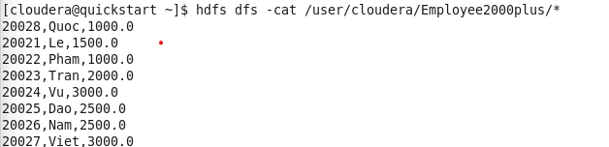

3. Load data from file **EmployeeNoheader.csv**  to a relation named **PigEmployee** and show the result

Required Figure 4: command to show the relation and the result



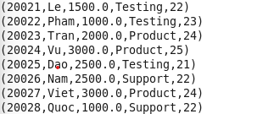

4. Create a relation named **PigEmployee2000plus** to store employees with **salary > 1500**

Required Figure 5: command to show results the relation and the result

5. Store data in PigEmployee2000plus to a Hive table name HiveEmployee2000plus and show the result

Required Figure 6: command to load data to hive table

Required Figure 7: command to show result and the result

6. Load data in **EmployeeNoheader.csv** to a relation named **PigEmployeeNoschema** without declaring datatype. Then from this relation, create another relation named **BonusSalary** with all data is same as that in **PigEmployeeNoschema** but **salary = salary + 500**